Getting Started
- What kind of data does pandas handle?
  - Pandas stores data in DataFrames
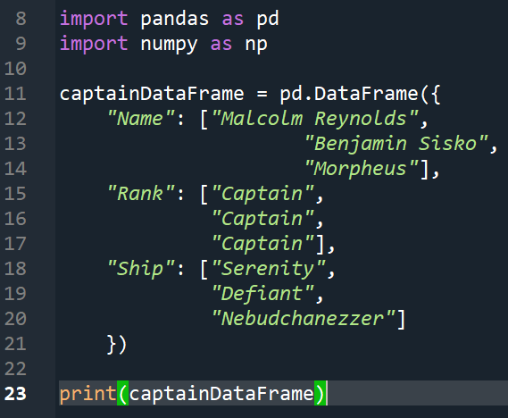
Output:
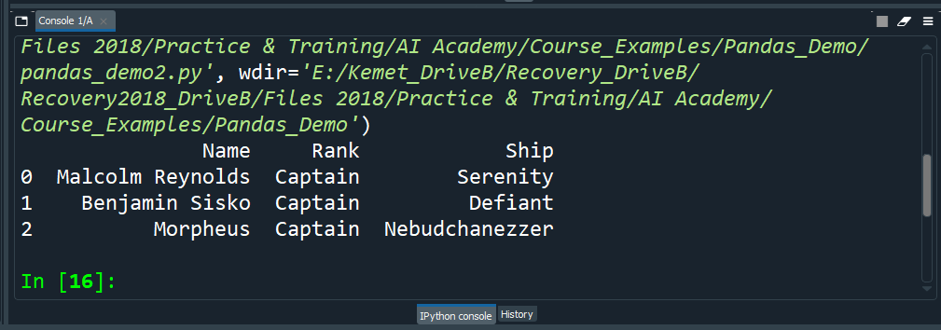
  - A DataFrame is a 2-dimensional data structure that can store data of different types such as
    - characters
    - integers
    - floating point values
    - etc
  - Each column in a DataFrame is a Series
    - When selecting a single column in a pandas DataFrame the result is a pandas Series
    - Series can be created with: pd.Series()
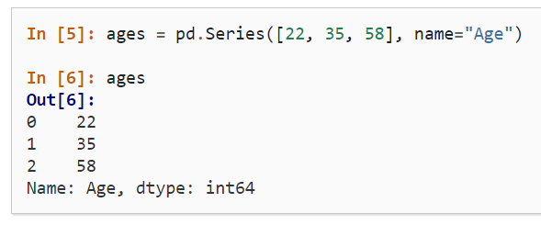
    - A pandas Series has no column labels, but it does have row labels
  - NOTE: The selection of a single column in pandas is similar to the selection of dictionary values in Python
  - Doing work with a DataFrame or Series
    - We can get information like the maximum or minimum value of a dataframe or series by applying the max() (or min()) function to the result variable
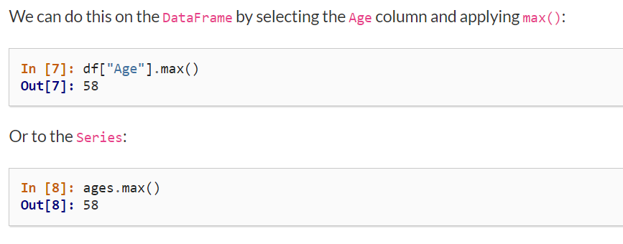
    - We can get a quick overview of the numerical data in a DataFrame with the describe() function
      - Text data is ignored by this function
      - Example:
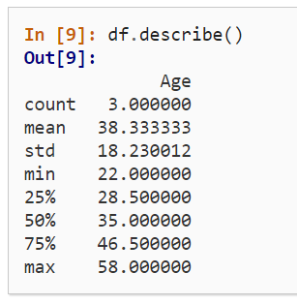
      - The describe() function returns a Series
  - NOTE: Pandas represents data as a table with columns and rows (much like a spreadsheet application)
    - The same data manipulations and calculations you'd do in a spreadsheet can be done in Pandas
- How do I read and write tabular data?
  - NOTE: If the editor cannot find the .csv file, try explicitly resaving it with the .csv extension; the original file's extension maybe incorrect
  - Pandas provides the .read_csv() function to read data stored as a .csv file into a pandas DataFrame.
  - Pandas supports many file formats including
    - csv
    - excel
    - sql
    - json
    - etc
  - Make sure to always have a check on the data after reading in the data.
  - When displaying the DataFrame the first and last 5 rows will be shown by default
  - To see the first n rows of the DataFrame use: <dataframe_name>.head(<number_of_rows>)
  - To see the last n rows of the DataFrame use: <dataframe_name>.tail(<number_of_rows>)
  - To see the column data types use: <dataframe_name>.dtypes
  - NOTE: dtypes is an attribute or characteristic (rather than a function) of the DataFrame and Series objects
  - To store pandas data to a file use the to_*() methods
    - Example:
    - NOTE: There is a subsequent .read_excel() function to read data from an Excel spreadsheet
  - Retrieving technical information about the data
    - The info() method retrieves technical information about Pandas data
    - Example:
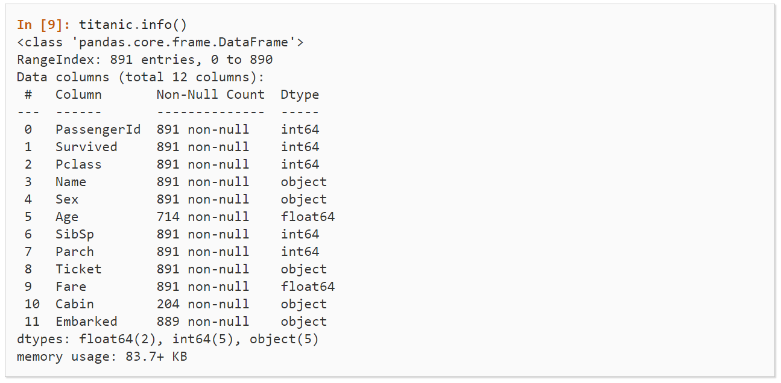Example 1: Information about the technical data retrieved
    - Summary of the data in the figure above:
      - It is a DataFrame
      - There are 891 entries (i.e. - 891 rows)
      - Each row has a label (index) from 0 to 890
      - The table has 12 columns
        - Most of the columns have a value
        - All 891 values are non-null
        - Some of the columns have missing values
        - The columns with text data (strings designated “objects” here):
          - Name
          - Sex
          - Cabin
          - Embarked
        - The remaining columns have numerical data
          - integers
          - floats
      - The kind of data in the different columns are summarized by listing their dtypes
      - The approximate amount of RAM used is also listed
- How to select a subset of a DataFrame
  - Selecting specific columns
    - To select a single column use the [ ] with the selected column name
    - Example:
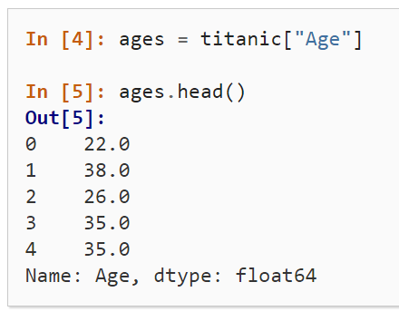
    - NOTE: Each column in a dataframe is a series
    - To select multiple columns use a list object
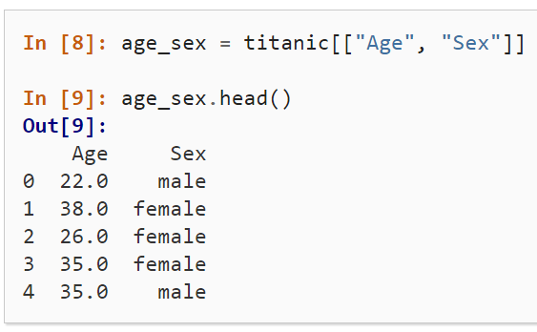
      - The returned datatype is a DataFrame
  - Filtering specific rows from a DataFrame
    - To select rows based on a conditional expression define the condition inside the selection brackets
    - Example
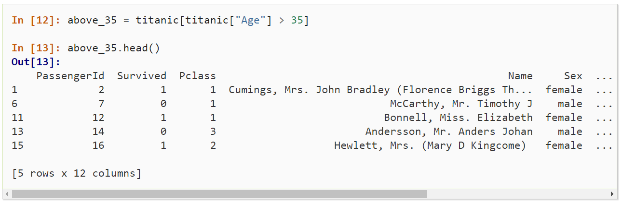
    - The output of conditional expressions is a Series of Boolean values with the same number of rows as the original DataFrame
    - By placing the conditional between the [ and ] (as in the example above) only the values that are True will be returned
    - You can also determine how many rows meet the condition by looking at the shape of the DataFrame
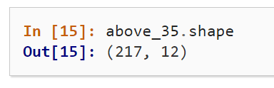
  - The isin() conditional function returns True for each value in the list argument
Example:
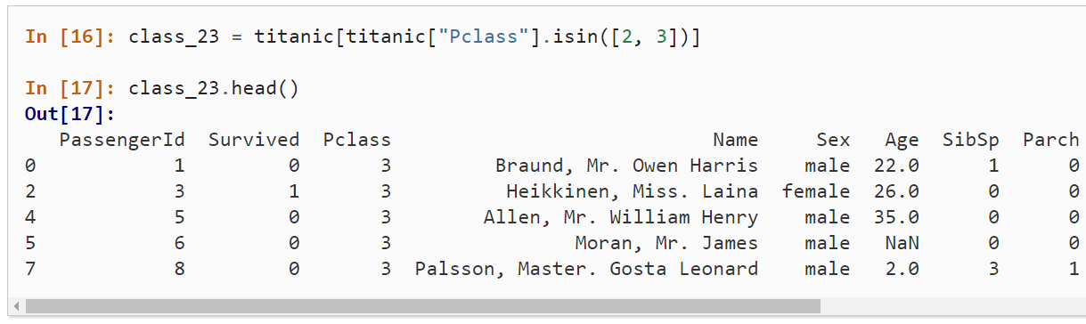
  - To filter the rows based on the conditional function, place the conditional function inside the selection brackets (as shown in the example above)
  - When combining multiple conditional statements each condition must be surrounded by parentheses
Example:
  - To retrieve values that are not Null use: .notna()
Example:
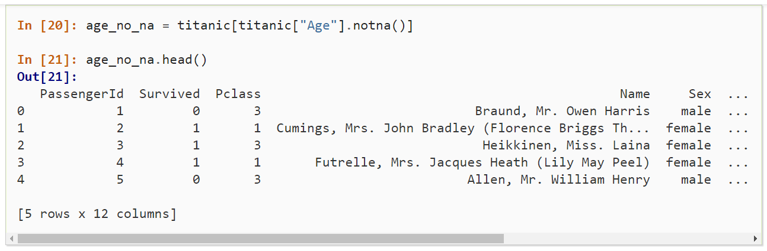
  - How to select specific rows and columns
    - The loc (or iloc) operators of the DataFrame is used to retrieve specific rows and columns
Example:
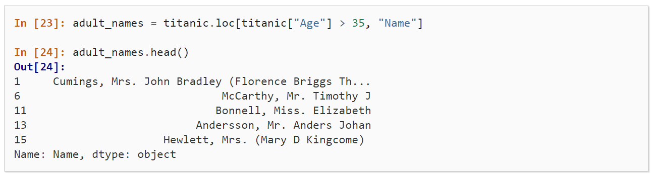
    - Syntax: <dataframe_name>.loc[<rows_condition>, <column>]
    - The values for loc[ … ] can be
      - a single label
      - a list of labels
      - a slice of labels
      - a conditional expression
      - a colon
    - To retrieve specific rows and columns given their numbers use iloc[ … ]
      - Syntax: <dataframe>.iloc[<row_num_start>:<row_num_end>, <col_num_start>:<col_num_end>]
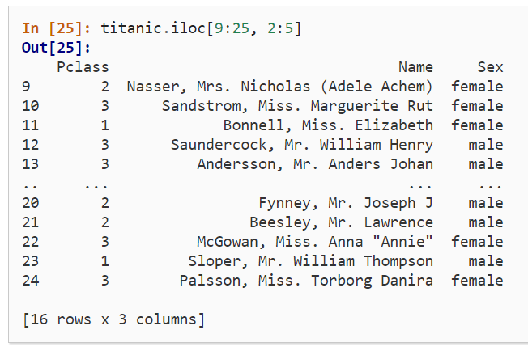
      - When selecting specific rows an/or columns with loc or iloc, new values can be assigned to the selected data
      - Example: Assigning the first 3 elements of the third column -
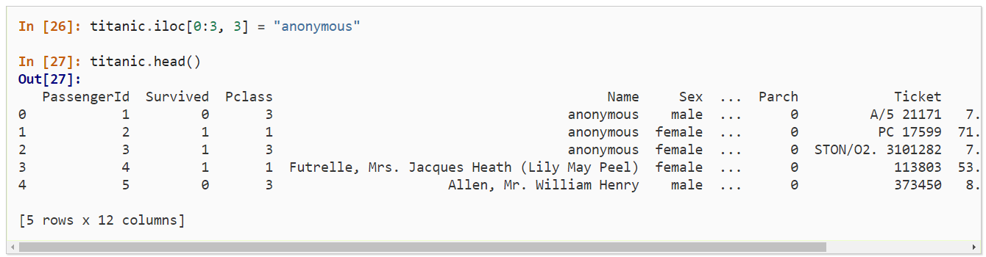
    - Summary
      - When selecting subsets of data, square brackets ( [ ] ) are used
      - Inside the brackets, you can use
        - single column/row labels
        - a list of column/row labels
        - a slice of labels
        - a conditional expressions
        - a colon
      - Select specific rows and/or columns using loc when the row or column names are known
      - Select specific rows and/or columns using iloc when the positions in the table are known
      - You can assign new values to a selection based on loc or iloc
  - How to create plots in Pandas
    - NOTE: In the example provided the index_col and parse_dates attributes
      - define the first column as the index of the resulting dataframe
      - convert the dates in the column to Timestamp objects
    - To get a quick visual check of the data
      - Example
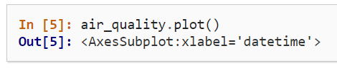
Output:
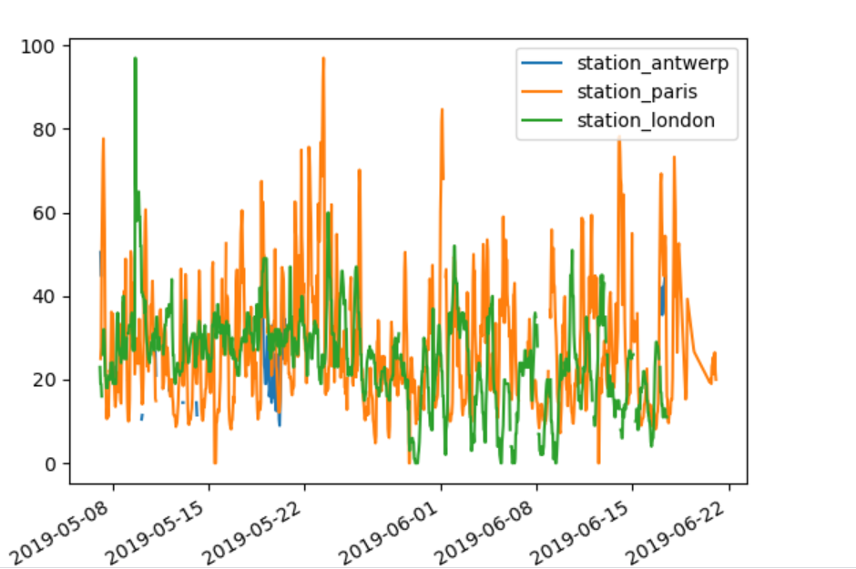
      - NOTE: The plot() method works on both Series and DataFrame objects
      - Additional example:
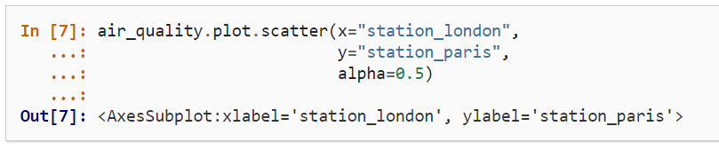
Output:
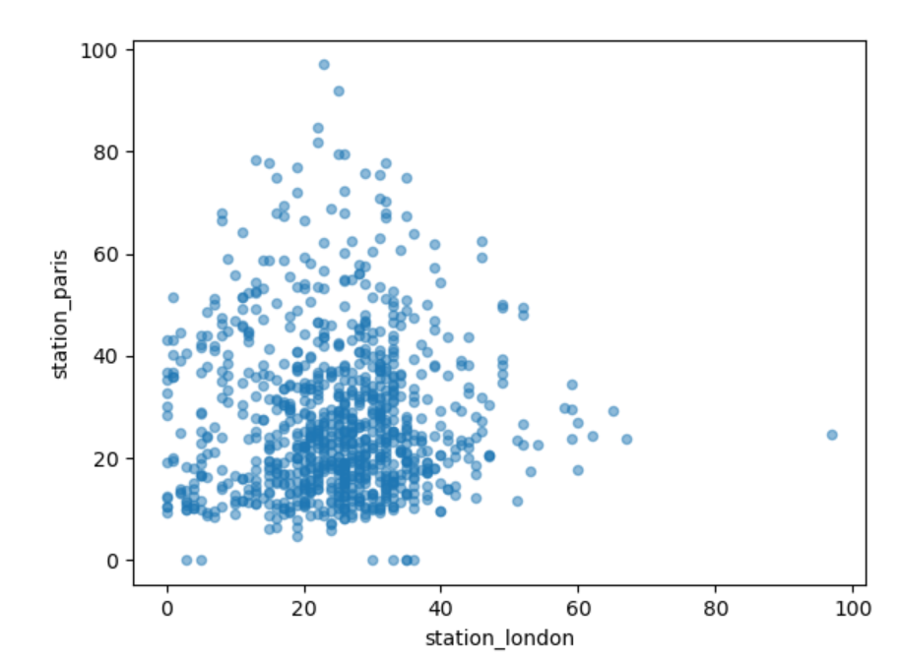

    - Apart from the default line plot when using the plot function, a number of alternatives are available to plot data
      - Example:
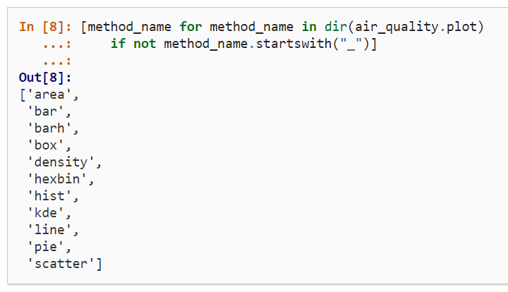
    - NOTE: Many development environments as well as ipython and jupyter notebook, use the TAB button to get an overview of the available methods:
      - Ex: air_quality.plot + TAB
    - Getting a boxplot
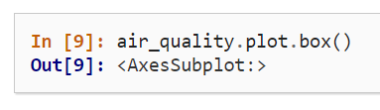
Output:
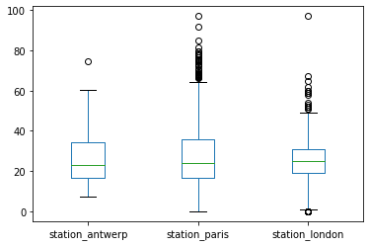
    - To get each column in a separate subplot:
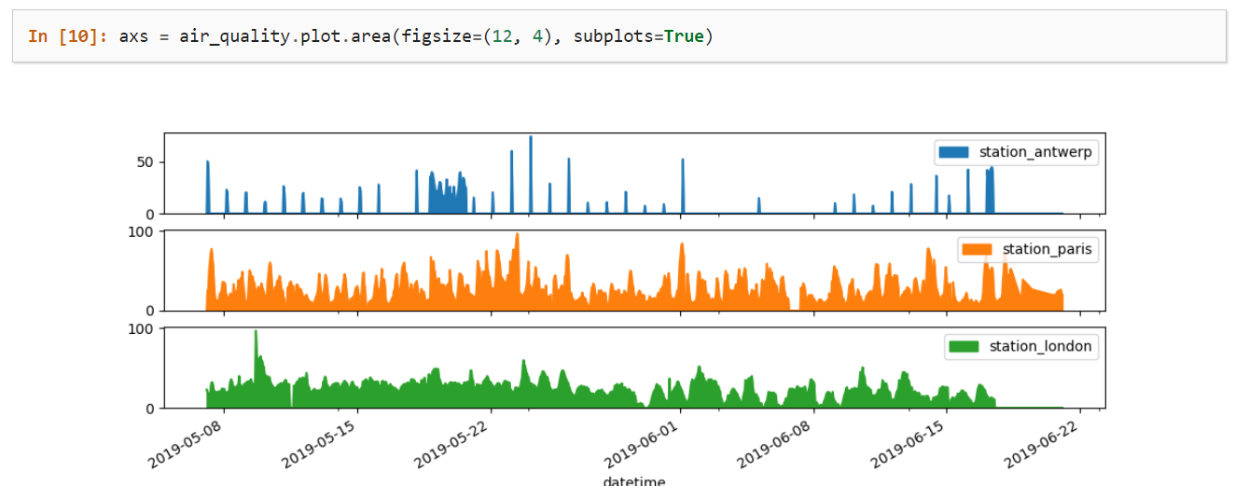
    - To customize, extend or save the result plot:
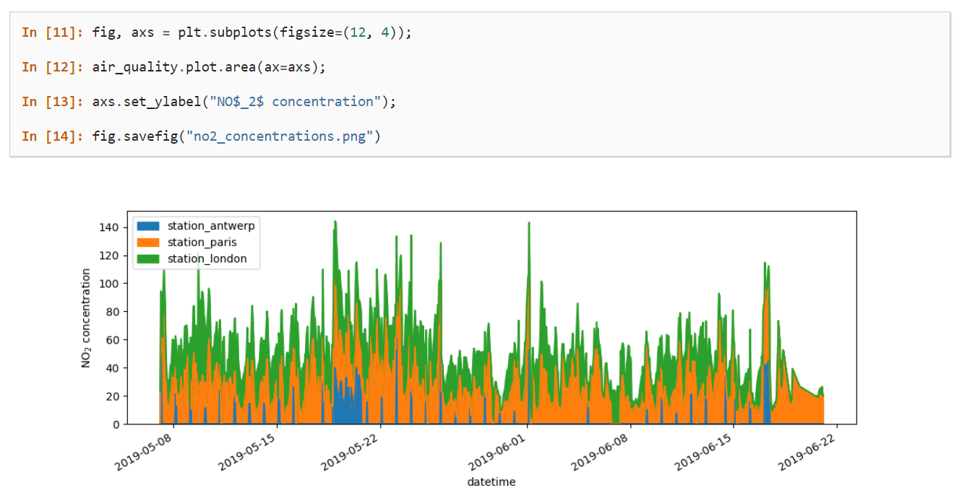
      - Each plot object created by pandas is a matplotlib object
      - Since Matplotlib provides many options to customize plots, making the link between pandas and Matplotlib explicit enables all the power of matplotlib to pandas plots
    - Summary:
      - The .plot.* methods are applicable on both Series and DataFrames
      - By default, each of the columns is plotted as a different element (i.e. - line, boxplot, etc)
      - Any plot created in pandas is a Matplotlib object
  - Creating new columns derived from existing columns
    - To create a new column, use the [ ] notation with the new column name at the left side of the assignment
    - Example:
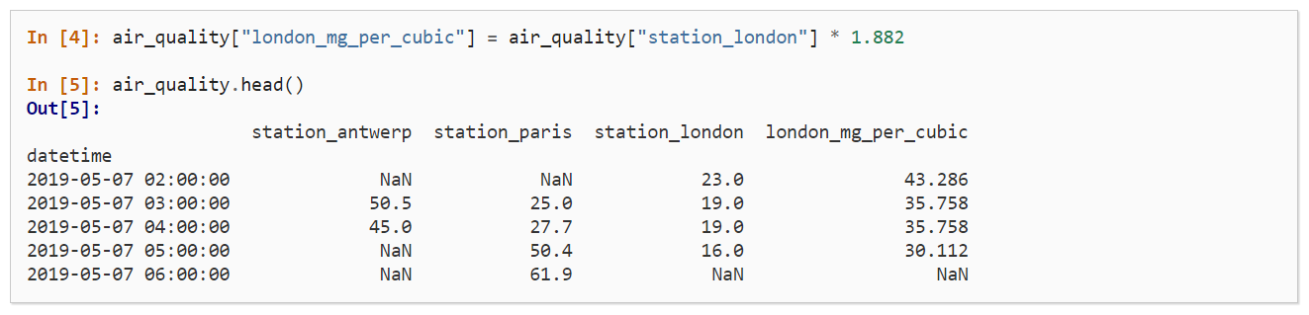
      - The calculation of values is done element wise
        - All the values in the selected column (i.e. - london_station) were multiplied by 1.882
        - Therefore a loop isn't needed to iterate through the rows
        - This works for all mathematical operators as well as logical operators (i.e. - <, >, ==, etc)
      - To rename data columns use the rename() function
        - It can be used for both row labels and column labels
        - Example:
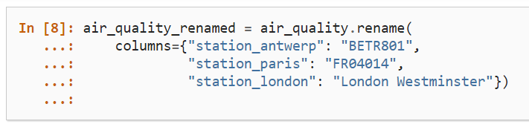
        - NOTE: The mapping isn't restricted to fixed names; mapping functions can be used as well, as in:
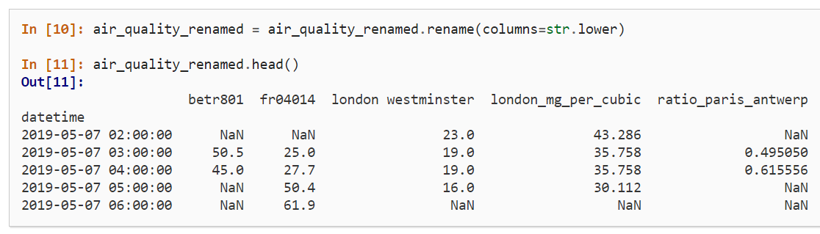
      - Summary:
        - Create a new column by assigning the output to the DataFrame with a new column name in between the [ ]
        - Operations are element-wise, so there is no need to loop over rows
        - Use the rename() function with a dictionary or function to rename row labels or column names
  - Calculating summary statistics
    - Aggregating statistics
      - Different statistics are available and can be applied to columns with numerical data
      - Operations in general exclude missing data and operate across rows by default
      - Example:
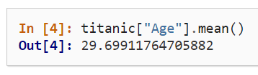
      - The statistic applied to multiple columns of a DataFrame (Reminder: the result of selecting multiple columns, is a DataFrame) is calculated for each numeric column
      - Example:
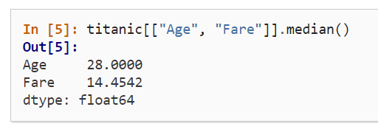
      - You can also customize aggregate statistic elements using the DataFrame .agg() function
        - Example
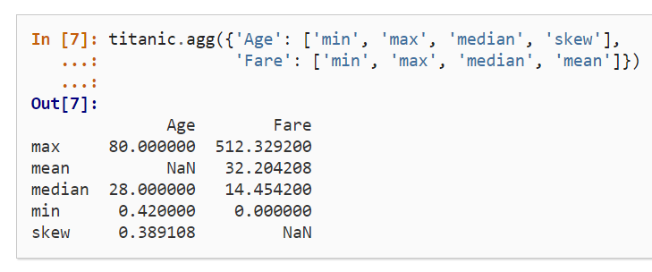
    - Aggregating statistics grouped by category
      - Example: What us the average age for male vs female Titanic passengers?
        - Since our interest is the average age for each gender, a subselection on these two columns is made first
          - titanic[[“Sex”, “Age”]]
        - Then we group them using the groupby() function
        - The average age for each gender is calculated and returned
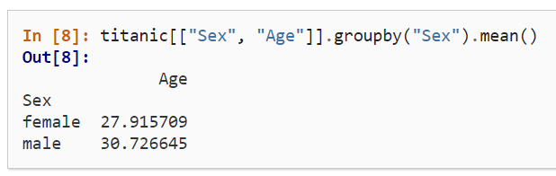
      - Calculating a given stat for each category in a cloumn is a common pattern: split-apply-combine
        - Split the data into groups
        - Apply a function to each group independently
        - Combine the results
        - NOTE: The apply and combine steps are typically done together in pandas
      - If the columns are not explicitly selected the methods (like mean()) are applied to each column containing numerical data
      - We can also use the following syntax:
<dataframe>.groupby(“<column_name>”)[“<column_name>”].<aggregate_function>()
      - Example:
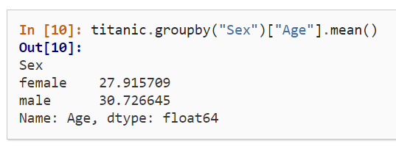
    - Count the number of records by category
      - The value_counts() method counts the number of records for each category in a column.
      - This method is a shortcut for the groupby() and count() methods
titanic.groupby("Pclass")["Pclass"].count()

      - NOTE: Both the size() and count() methods can be used in combination with groupby()
        - size() includes NaN values and provides the number of rows (i.e. - size of the table)
        - count() excludes any missing (including NaN) values
        - value_counts() uses the dropna argument to include or exclude the NaN values
    - Summary:
      - Aggregation statistics can be calculated on entire columns or rows
      - The groupby() method provides the power of the split-apply-combine pattern
      - The value_counts() method is a convenient shortcut to count the number of entries in each category or a variable
  - Reshaping the layout of tables
    - Sorting table rows
      - The sort_values() method sorts the rows according to the defined columns
      - The index will fillow the row order
    - Long to wide table format
      - Use the pivot() method strictly for reshaping of the data
        - a single value for each index/column combination is required
      - Since pandas supports plotting of multiple columns, the conversion from long to wide table format enables the plotting of the different time series at the same time
    - Pivot table
      - The pivot() method rearranges only the data in a table
      - The pivot_table() method is used to aggregate multiple values
        - You must provide an aggregation function (such as mean()) which indicates how to combine the values
        - For example when calculating the summary of columns for each variable separately we can set the margin parameter to True
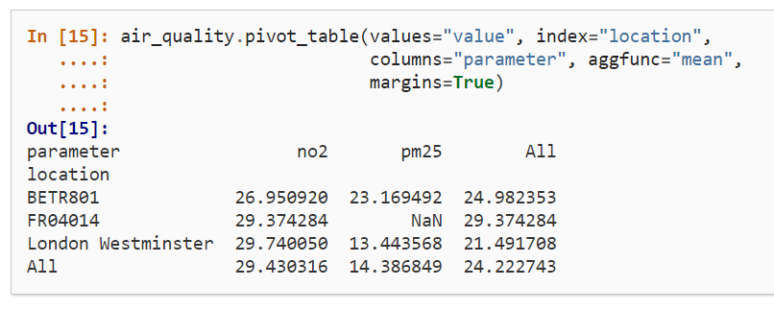
        - NOTE: The pivot_table() method is linked to the groupby() method. Therefore, we can achieve the same result as the example above with
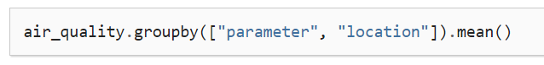
    - Wide to long format
      - The melt() method (on a DataFrame) converts the data table from wide format to long format
      - The column headers become the variable names in a newly created column
      - The melt() method will “blend” all columns not mentioned in id_vars together into two columns
        - A column with the column header names
        - A column with the values (default name: values)
      - The melt() method also has a number of parameters (for example):
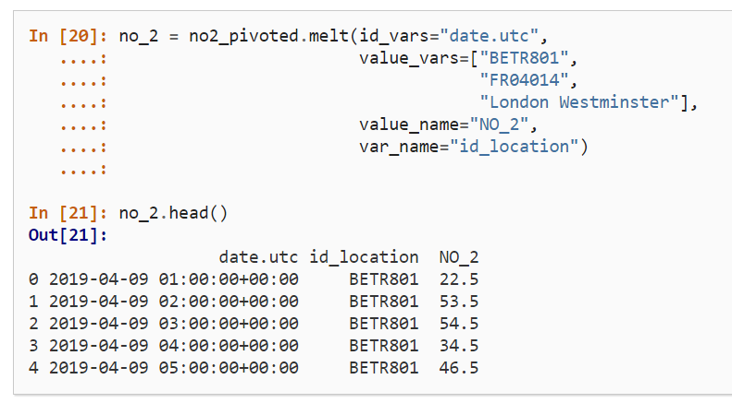
        - value_vars – defines explicitly which columns to “melt” together
        - value_name – provides a custom column name for the values column instead of the default column name (value)
        - var_name –
          - provides a custom name for the column collecting the column header names
          - otherwise is takes the index name or the default name variable
    - Summary:
      - Sorting by one or more columns is supported by sort_values
      - The pivot() function is purely for restructuring of the data
      - pivot_table() supports aggregation of tables
      - The reverse of pivot() (long to wide format) is melt() (wide to long format)
  - Combining data from multiple tables
    - The concat() function performs concatenation operations of multiple tables along one of the axes (either row-wise or column-wise)
    - By default concatenation is along the 0-axis so the resulting table is a combination of the rows of the input tables
    - NOTE: The axis argument will return the number (?) of pandas methods that can be applied along an axis
      - The DataFrame has two corresponding axes:
        - The first running vertically down the rows (0-axis)
        - The second running horizontally across the columns (1-axis)
        - Most operations (i.e. - concatenation or summary statistics) are against rows, by default; but they can be applied against columns, as well
    - We can apply the sort_values() method against the resulting DataFrame
    - The concat() function's keys argument can help identify which data belongs to which table
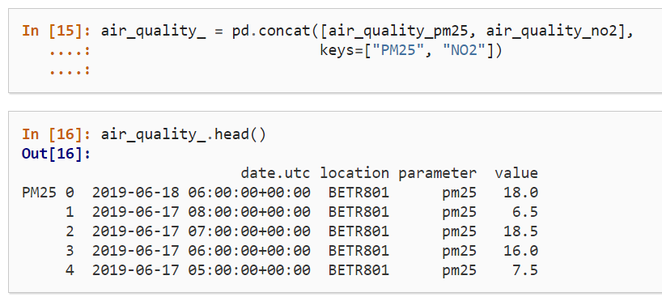
    - NOTE: Hierarchical indexing or MultiIndex is an advanced and powerful pandas feature to analyze higher dimensional data
      - While MultiIndex is not in the scope of the tutorial note that the function reset_index() can be used to convert any level of an index to a column (e.g. - air_quality.reset_index(level=0))
    - Join tables using a common identifier
      - The examples are taken from data (air_quality_stations.csv) that must be installed from the py-openaq package
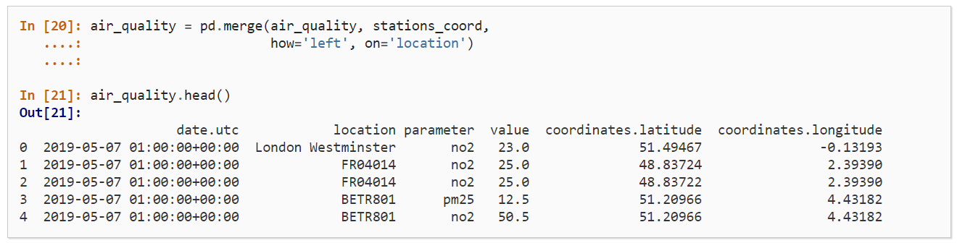
      - Using the merge() function for each of the rows in the air_quality table, the corresponding coordinates are added from the air_quality_stations_coord table
      - Since both tables have a location column, that is used as a key to combine the data
      - Choosing the left join only the locations available in the air_quality table end up in the resulting table
      - The merge() function supports multiple join options similar to database-style operations
      - Example: Adding parameter, full descriptio, and name from the air_quality_parameters.csv file (also installed with py-openaq)
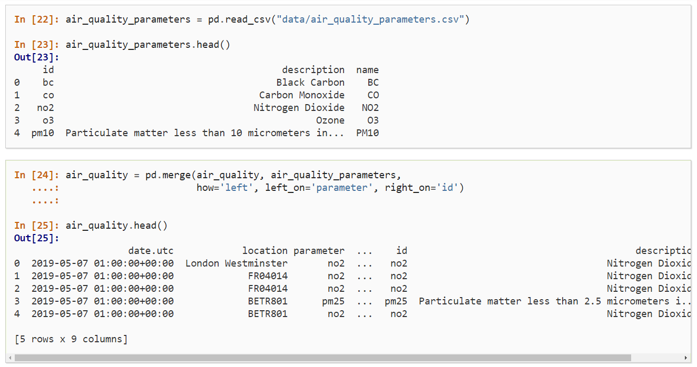
      - In the above example there is no common column name
      - The parameter column (in the air_quality table) and the id column (in the air_quality_parameters_name table) both provide the measured variable in a common format
      - The left_on and right_on arguments are used to make the link between the two tables
      - Summary:
        - Multiple tables can be concatenated both column-wise and row-wise using the concat() function
        - For database-like merging and joining of tables, use the merge() function
  - Time series data
    - The values in the datetime column (see example) are character strings, and don't have any datetime operations
    - Use the to_datetime() function to convert the string to a datetime object
    - NOTE: Since many data sets contain datetime information in one of the columns, pandas input functions such as read_csv() and read_json() can transform dates by using the parse_dates parameter with a list of columns to read as a Timestamp object
    - Using Timestamps for datetime data
      - Timestamp objects enables us to perform calculations on date information or compare dates
      - Pandas Timestamp objects provide many time-related properties such as:
        - month
        - year
        - weekofyear
        - quarter
        - etc
    - We use the split-apply-combine pattern to group on a datetime property such as weekday
      - The weekday property enumerates the days of the week where Monday = 0 and Sunday = 6
      - We use the dt property of the pandas Timestamp object
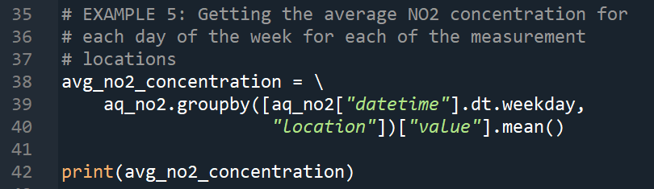
      - NOTE: The example works with a very short time series, therefore the analysis does not provide a long-term representation
    - To represent the data in a plot: Plot the typical NO₂ pattern during the day of all stations together
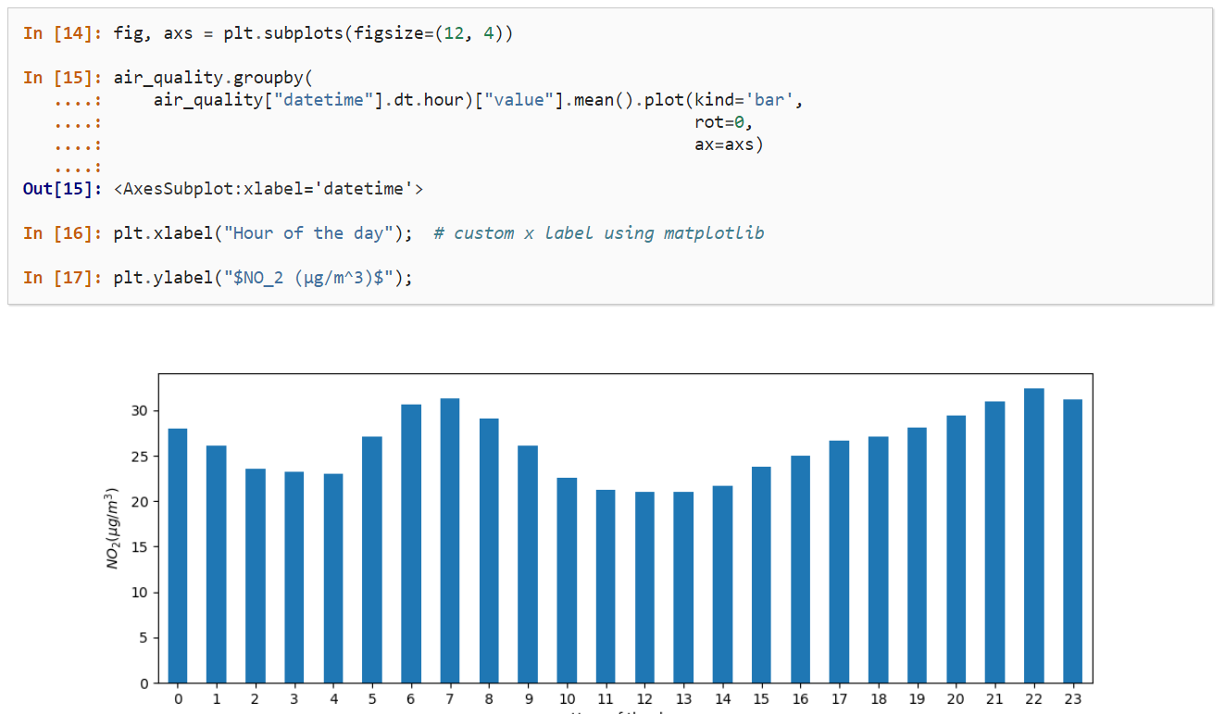
    - We use the split-apply-combine approach to calculate the given statistic (i.e. - mean NO₂ concentrations) for each hour of the day
  - Datetime as an index
    - NOTE: In the section on pivoting data we set the datetime information as the index. However, setting a column as an index can also be achieved with the set_index() function
    - Recall that we can reshape a table using the pivot() function
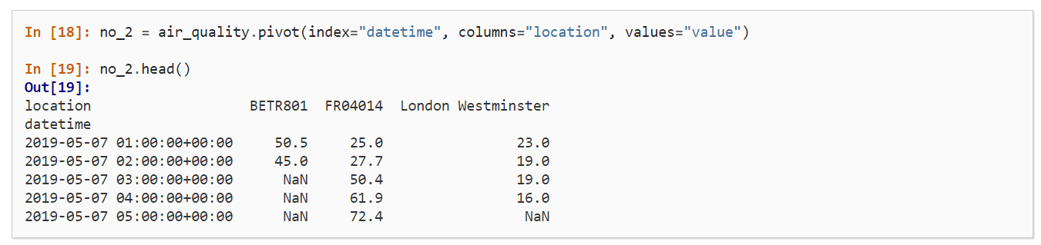
    - Working with a datetime index (DatetimeIndex) provides powerful functionalities
      - With the DatetimeIndex, the dt accessor is no longer needed to get the time series properties
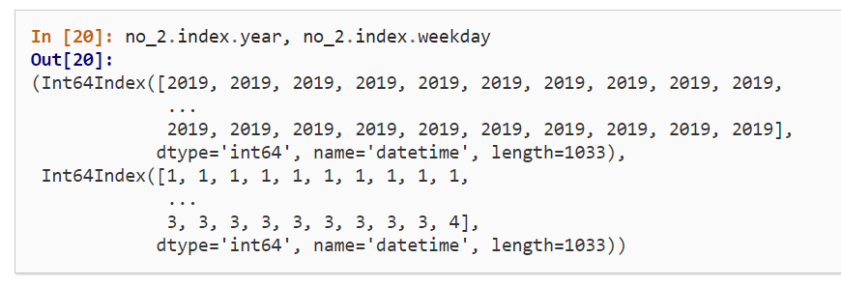
    - By providing a string that parses to a datetime, a specific subset of the data can be selected on a DatetimeIndex
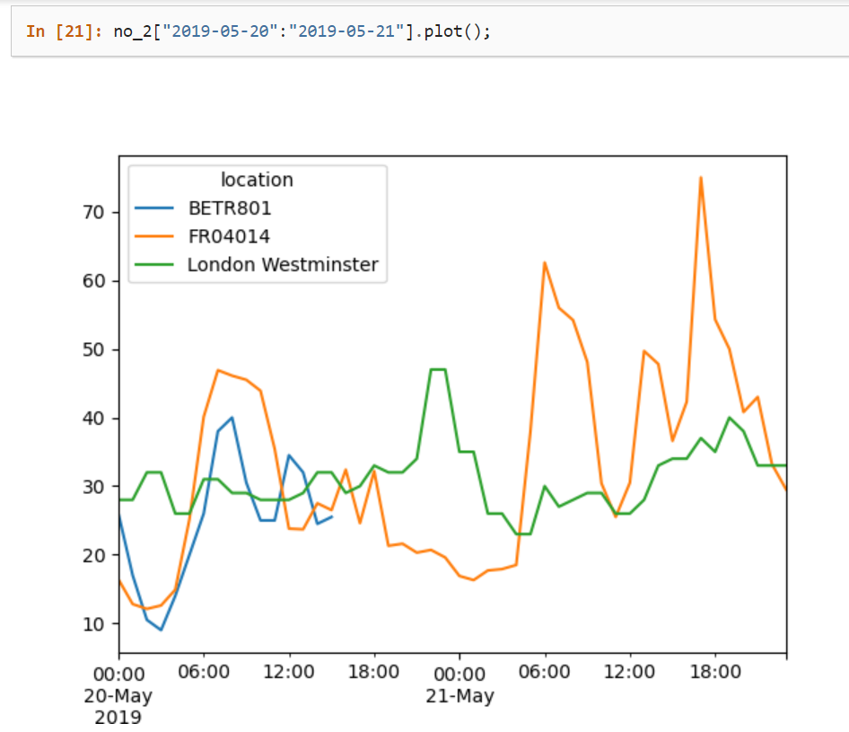
  - Resampling a time series to another frequency
    - The resample() method is used to change a time series to another frequency. For example, to convert data in seconds to data in minutes
    - The resample() method is similar to the groupby() method
      - It provides a time-based grouping, by using a string (i.e. - “M”, “5H”, etc) that defines the target frequency
      - It requires an aggregation function such as mean() or max()
    - When defined, the frequency of the time series is provided by the freq attribute
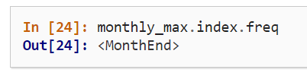
    - Summary:
      - Valid date strings can be converted to datetime objects with the to_datetime() function or as a part of read functions
      - Datetime objects, in pandas, support calculations, logical operations, and convenient date-related properties using the dt accessor
      - A DatetimeIndex contains date-related properties and supports slicing
      - resample() is a powerful method that changes the frequency of a time series
  - How to manipulate text data
    - String methods are available using the str accessor
    - String methods work element-wise and can be used for conditional indexing
    - The replace() method can be used to convert values based on a given dictionary
